**Nakul Patel Exercise 5**

Question 1

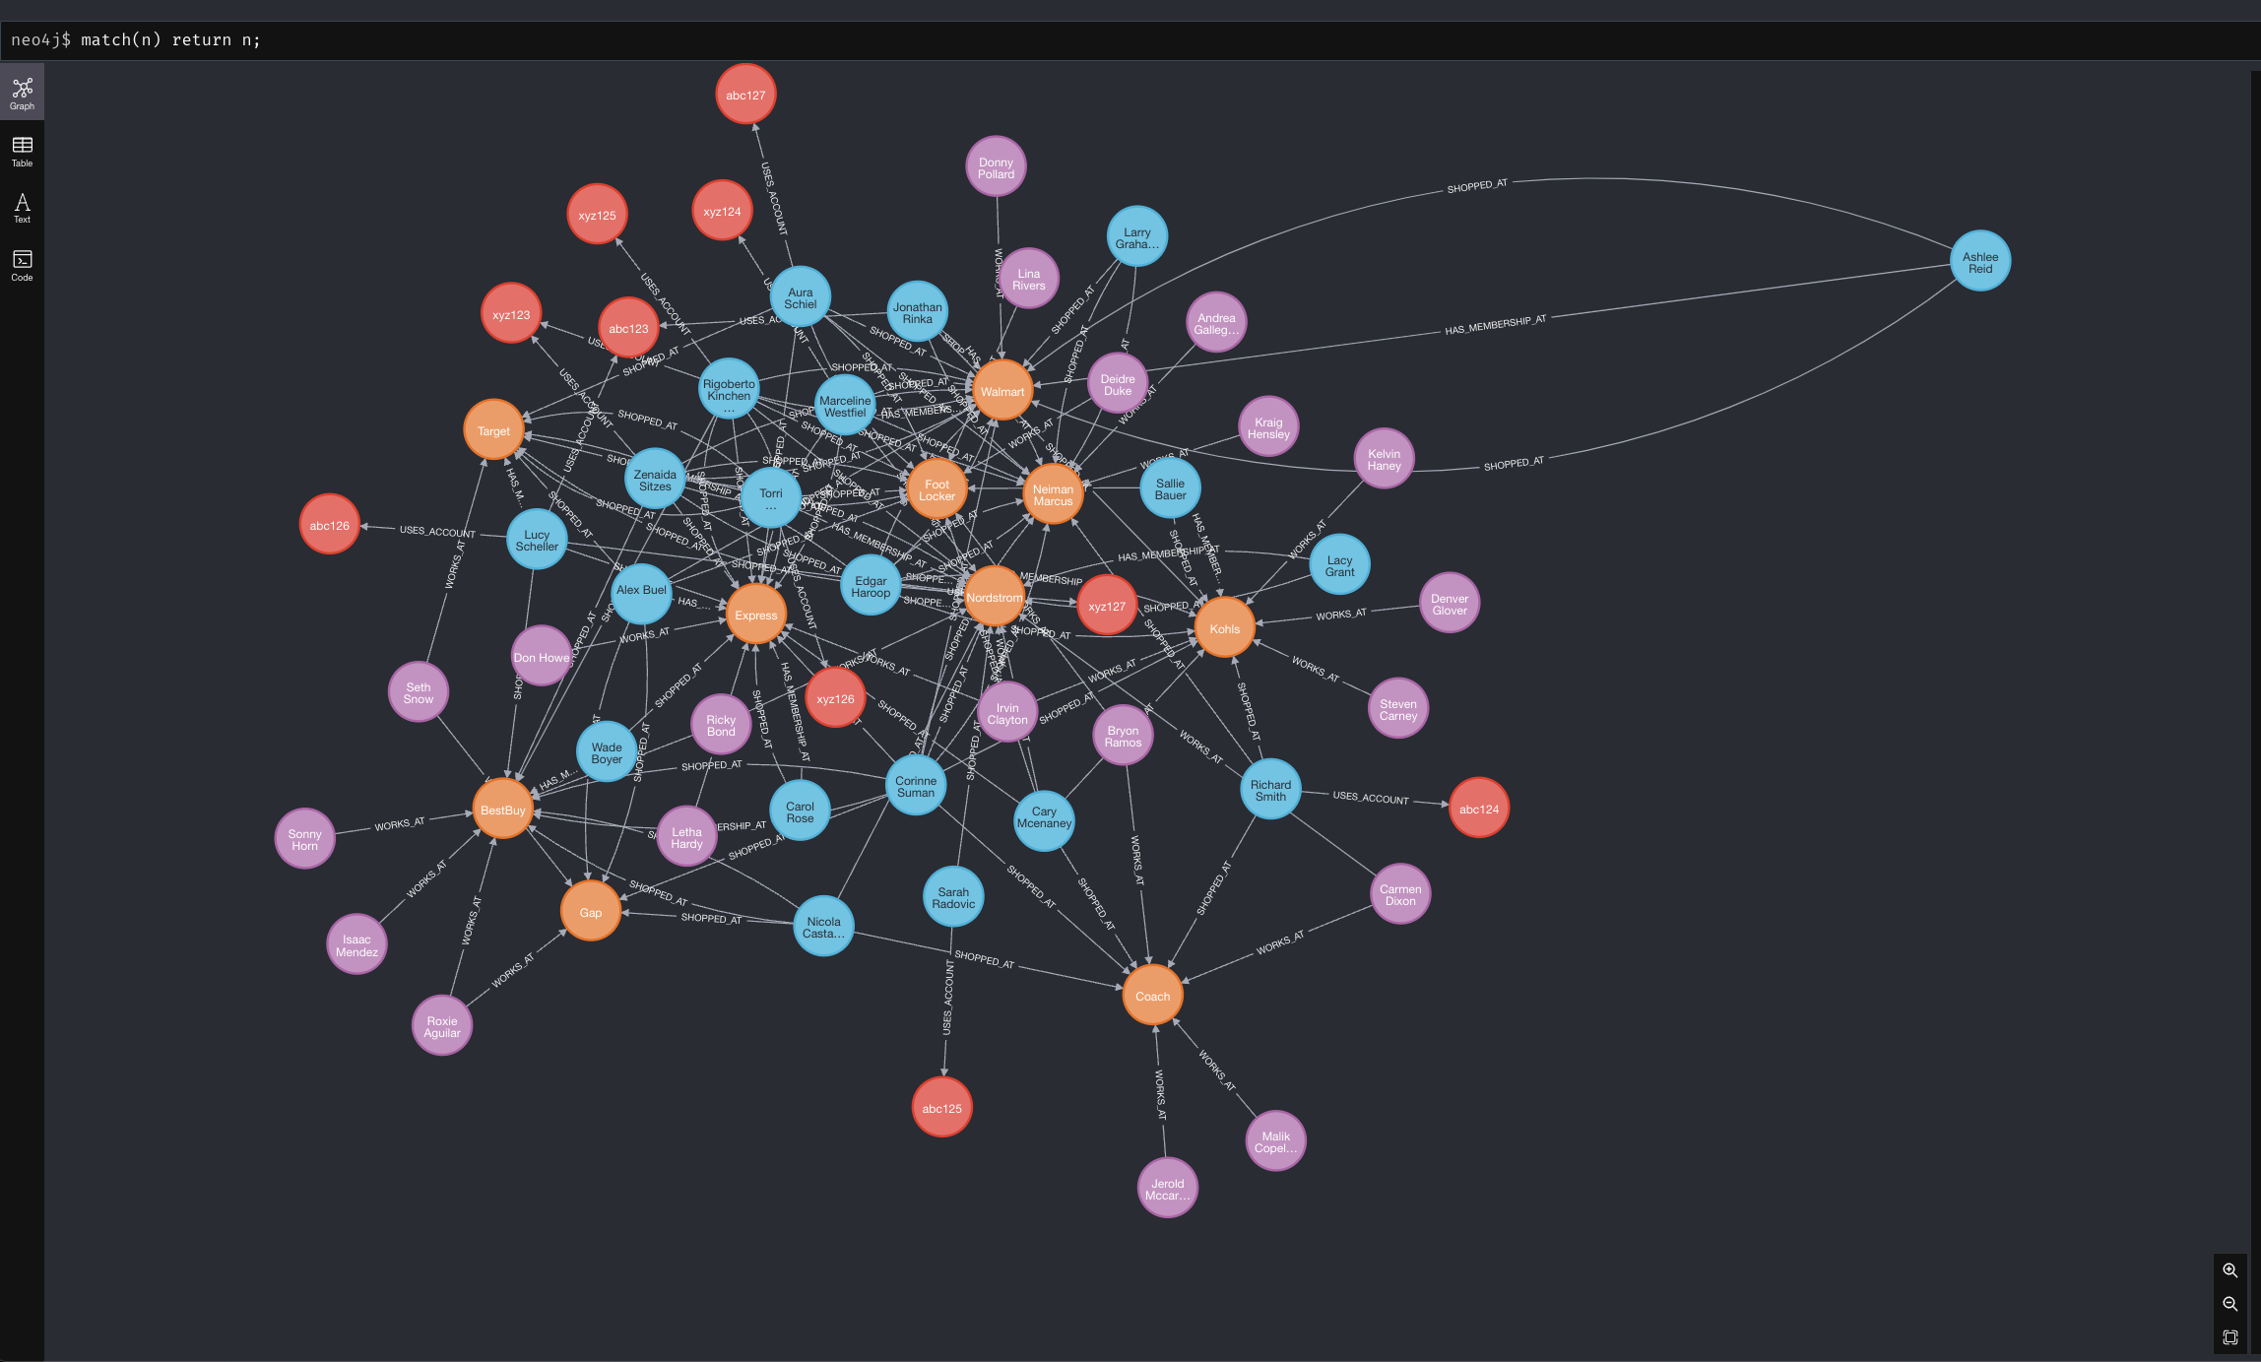

Question 2

Question 3

Question 4

Question 5

Question 6

Question 7

Question 8

Question 9

Question 10

